Seminar: Vibrtions and Structure-borne sound in Civil Engineering – Theory and Applications

A short introduction to room acoustics

Yum-Ji Chan

April – May 2006

Abstract

Sound waves are mechanical waves and the behaviours of fixtures inside rooms are governed by rules in physics. These fixtures are classified into three groups: reflectors, diffusers and absorbers, and the physical properties are investigated. The important parameters in determining acoustic quality of rooms are introduced. On the other hand, it is shown that limitations exist on applying these parameters. A brief introduction of solving room acoustic problems by the finite element method is made at the end.

Contents

1 Introduction: Nature of sound 3
1.1 Measurement of Sound intensity 4
1.2 Wave phenomena 4
2 Elements controlling sound in a room 6
2.1 Reflectors 6
2.2 Diffusers 7
2.3 Absorbers 8
3 Parameters in room acoustics 11
3.1 Impulse response function of a room 12
3.2 Reverberation time 14
3.3 Clarity / Initial time delay gap 14
3.4 Binaural quality index 15
3.5 Limitations 16
3.6 A failed example 17
4 Solving room acoustic problems with the finite element method 18
4.1 Numerical error 19
5 Conclusion 20

Introduction: Nature of sound

Sound waves are mechanical waves generated by vibrating air molecules. That vibration propagates at the speed of sound in air, c. It is usually taken as 340m/s in calculations, but this can vary according to atmospheric pressure and temperature. The wavelength of sound λ can be calculated by c = f · λ, where f stands for frequency in Hz (cycles per second). For example, sound waves at 500 Hz have wavelengths of 68 cm in air. The frequency ranges of common musical instruments are shown below:

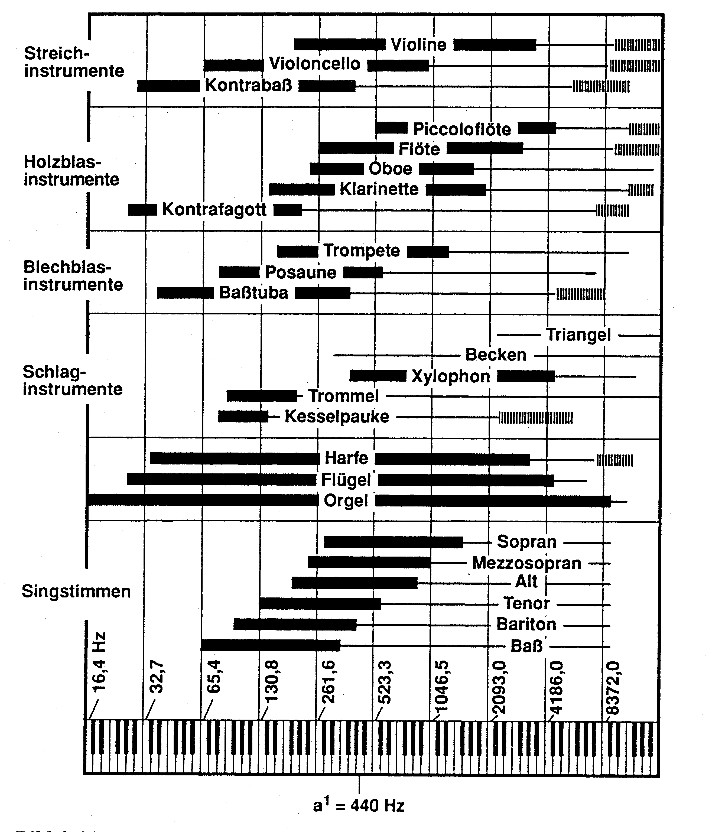

Measurement of Sound intensity
To determine the sound intensity, the amplitude of pressure variation, called acoustic pressure, is measured. Also, as human beings usually “feel” the physical quantities in logarithmic scales according to Weber-Fechner law, the logarithmic scale of acoustic pressure is taken. The final result is a parameter called sound pressure level (SPL):
$$\text{SPL}=\text{20}⋅\text{log}\left(\frac{p}{p_{\text{ref}}}\right)$$
Here p_{ref} = 2 × 10⁻⁵ Pa. On the other hand, acoustic power level (SWL) represents level of emission of sound sources. It is calculated by
$$\text{SWL}=\text{10}⋅\text{log}\left(\frac{w}{w_{\text{ref}}}\right)$$
Here w_{ref} = 10⁻¹² Watt. SPL and SWL are the basic scales to measure sound intensity in room acoustics. On the other hand, more parameters are necessary in measurements related to environmental noise, which is beyond our scope.

Wave phenomena

Sound waves have much longer wavelengths than light waves. Wavelengths of visible light are at around 10⁻⁷ m. Therefore, we can say that rules for waves (e.g. interference) are more important than rules for rays when further properties are derived.

To proceed with our wave approach, we have to consider Huygen’s principle. The definition in wikipedia reads [Wi06]

It recognizes that each point of an advancing wave front is in fact the center of a fresh disturbance and the source of a new train of waves; and that the advancing wave as a whole may be regarded as the sum of all the secondary waves arising from points in the medium already traversed.

Applying Huygen’s principle can explain the existence of edge diffusion and the formation of Fresnel zones. These make the theory involved in acoustic reflectors is more complicated than those for light, particularly in sizing.

Fresnel zones are better explained by the experiment below [Cr82]. A source (S) and a receiver (R) are placed in front of a circular plate. The circular plate is made up of an inner circle ( hatched / ) and an outer ring ( hatched \ ).
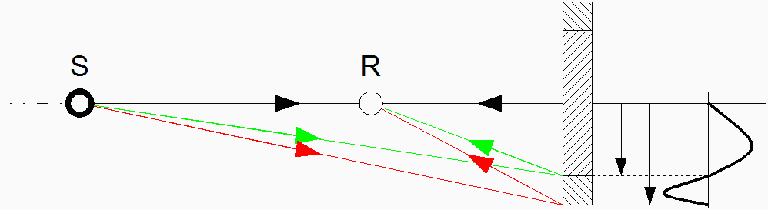

Imagine that the path lengths of
- the black beam is nλ,
- the green beam is (n + ½) λ and
- the red beam is (n + 1) λ.

We can observe two issues from the diagram. Firstly, the magnitude of reflected sound wave measured at R depends on the presence of the outer ring:
- If the outer ring is removed:
The red beam is not present, only the black and green rays exist. As all reflected rays have path lengths between nλ and (n + ½) λ, they have similar phases and the sound intensity received by R is very high;
- If the outer ring is in place:
All three beams are present. R receives rays with path lengths between nλ and (n + 1) λ. The sound level received by R is very small because sound waves with all phases with similar magnitudes are received, leading to destructive interference.

Secondly, the reflected energy received by R is very small if the reflector is made too small. This is because a large amount of sound energy is not reflected. This phenomenon determines the minimal size for reflectors. This will be discussed in later sections.

Elements controlling sound in a room
Although many kinds of fixtures exist around a room, they can be arranged into three groups:
- Reflectors
- Diffusers
- Absorbers

The properties of these devices are discussed below.

Reflectors
Reflector is the simplest acoustic device on the walls – all walls are essentially reflectors. However, because sound waves are mechanical waves, the mechanical properties of the walls affect the performance of reflction. There are two particularly important features of a wall: Mass per unit area and size.

Firstly, a piece of wall is considered as a rigid body with known mass. It is because the stiffness of the walls is significant only at very low frequencies. The free body diagram of the wall is shown below:

p₁
p₂
mü

By Newton’s second law of motion, p₁ - p₂ = - (2πf)²mu, where m is the mass of the wall per unit area and u is the amplitude of vibration of the wall. If the difference of acoustic pressures is small, it means that the sound intensities inside and outside the room are similar, and acoustic energy is being removed from the room. This can happen if m is not large enough. Therefore a good reflector should be heavy, and it performs better under high frequencies. Further derivation can be found in [Cr82].

Secondly, it is explained that the size of reflectors should not be too small. Nevertheless, there is no need to enlarge it infinitely while ignoring other factors. Similar to reflectors for light waves, there is little effect on sizing if the reflecting surface is large enough.

Diffusers
Acoustic diffusers are necessary to spread acoustic energy evenly within a room. It is done because
- sound waves of higher frequencies should be scattered to compensate for its directivity, or
- an “intimate” sound is heard when it comes from multiple directions.

The diffusers fulfilling these two criteria are different. Type A below is used to scatter the wave pattern, which resembles a roughly-polished mirror. The dimensions of the grooves are designed to be similar to the wavelength of sound at target frequencies. On the other hand, type B acts as a convex mirror. Sometimes a group of these diffusers are hung on the ceiling. It can reflect a point sound source to all audiences. In addition to that, some audiences can hear the reflections from two diffusers, thus having the feel of the sound coming from two places.
Type A
Type B

Absorbers
When absorbers are talked about, many people think of fabrics and porous materials at the first instant, because they absorb shocks. Contrary to popular opinion, these are effective absorbers only at the high frequency range. Moreover, these are usually not necessary because clothes worn by people present already provide the same kind of damping. Fabrics are attached to the walls only in rooms where sound should be damped heavily, for example in lecture rooms.

Absorbers for low and mid- frequency ranges have other designs. These devices make use of the principles in structural dynamics. They “suck” energy from the room by resonance of themselves, and energy is removed from that device by both damping (to heat energy) and back into the room as shown below:

Physical system 1  The room | Physical system 2  Low frequency resonator | Dissipated energy
The room contains 6 units of energy initially | Absorbing energy by resonance | Energy dissipation by structural damping / damping within air
 | e

3 Units remain after the process

The important types of absorbers based on structural dynamic principles are listed below.

Hemholtz resonator-based structures [Ch04]. To absorb acoustic energy at mid frequency range, devices are designed to be similar to a Helmholtz resonator. The diagram below shows a typical Helmholtz resonator, named after Hermann von Helmholtz (1821 - 1894) because he was the first person to use it extensively.
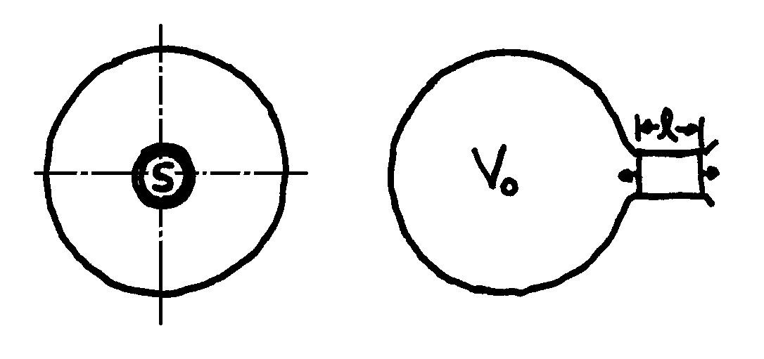
Both mass and spring in a Helmholtz resonator are provided by air molecules, as the air in the bulb behaves like a spring and air in the neck behaves in the way of a mass. The resonant frequency of a Helmholtz resonator is determined by the volume of the glass bulb, the length and the cross-section of the neck and the speed of sound.
Low frequency absorbers. Thin plates are used to absorb low frequencies. When the wavelength of bending wave in the plate is longer than the wavelength of sound at the same frequency, there exists an incident angle that acoustic energy can be transferred to the bending motion of the plate.

Other designs. Some new absorber designs have emerged in the past decades. One of them is called a composite plate resonator (Verbundplatten-resonator or VPR in German). It consists of a thin metal plate over a porous volume surrounded by gypsum boards. A photo of a VPR resonator is shown below.
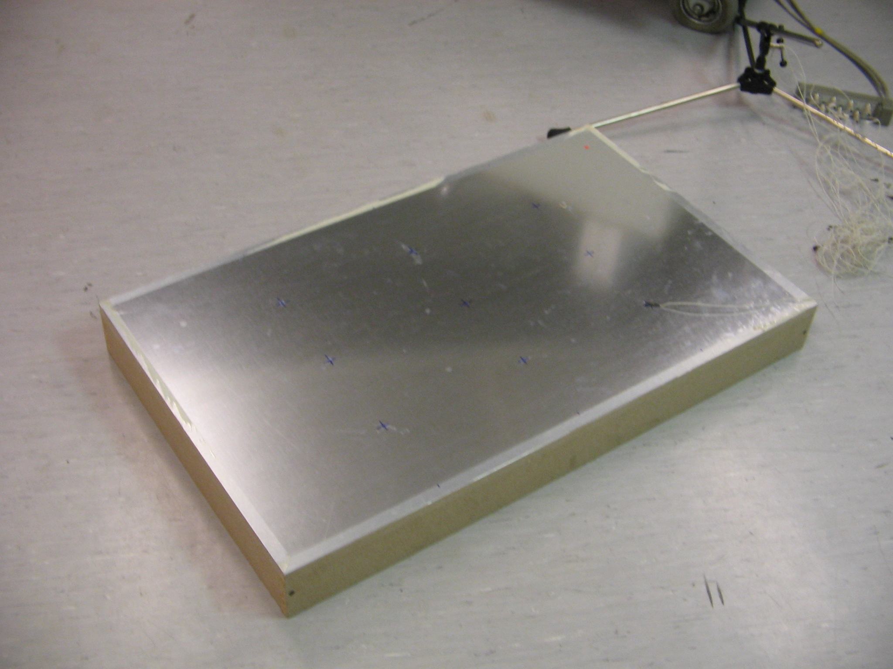
The acoustic properties of a VPR resonator and a metal plate are compared by simulation. The finite element (FE) analysis was employed and a resonator was modelled as a fluid-solid coupled assembly with the FE. In systems of equations representing fluid-solid coupled assemblies, asymmetric FE matrices are encountered although the FE matrices are usually symmetric. It is due to the coupling conditions and is not a violation of Maxwell-Betti reciprocal theorem. The graph below compares the eigenfrequencies [Ch06] of
- A metal plate (Uncoupled, U) and
- A VPR resonator (Coupled, C).

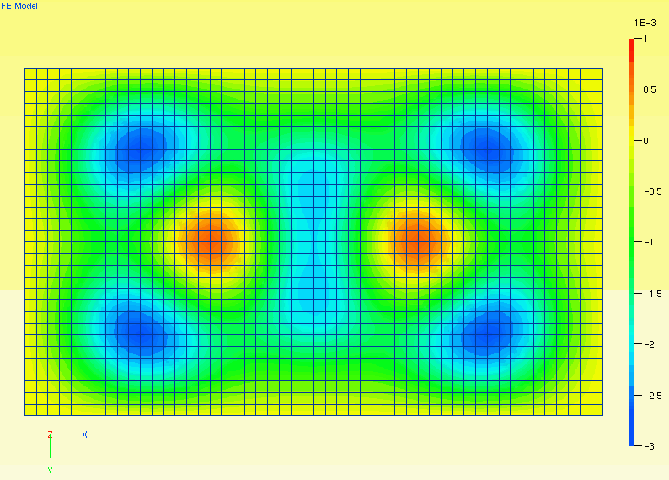
Characteristic
eigenfrequency
of the resonator

The eigenfrequencies in a VPR resonator is usually lower than in a metal plate when similar modes are compared. The only exception is the first eigenfrequency, which h is the characteristic eigenfrequency of the structure. To explain the results, the Rayleigh quotient is considered. It is an estimation of eigenfrequency:
$$ω^{2}≈R=\frac{x^{T}\text{Kx}}{x^{T}\text{Mx}}$$
With a large amount of air under the plate vibrating without compression, the denominator increases a lot but only minimal increase is encountered in numerator. Therefore the Rayleigh quotient decreases and so do the eigenfrequencies.

Absorbers are used with care because they remove acoustic energy from the room. They are particularly avoided in big concert halls, because the energy received by each audience is already little.

Parameters in room acoustics
Past experiences have shown that the following parameters are the most important in determining the acoustic quality of a room:
- Reverberation time
- Clarity / Initial time delay gap
- Binaural quality index

Impulse response function of a room
All three parameters depend on the impulse response function. It is the sound intensity profile after an impulse excitation (e.g. shooting a gun or electric spark in tests). A typical profile is shown below. With an impulse excitation multiple response impulses are detected, due to reflections by the walls. The first reflections are distinguishable while the later ones are more diffused. The sound field generated by multiple reflections of an impulse is called reverberation.

Direct sound
First reflections (early sound)

Reverberation

1

2

3

4

Energy
Time
An impulse response function can be sought by examining either a physical or a numerical model. Numerical models are used extensively nowadays because the cost involved is lower. To make use of the impulse response function onto an arbitrary sound source, convolution is used.

Convolution is a mathematical tool to deal with response of a structure under excitation. It is assumed that the excitation signal can be chopped down into infinite number of impulses, and the response under the whole excitation signal is the superposition of the response functions generated by those “excitation impulses”.

It is expressed mathematically as
$$y\left(t\right)=\int_{0}^{+∞}{x\left(t\right)h\left(t−τ\right)dτ}$$
. However, according to the principle of “effect comes after excitation”, h(t) = 0 when t < 0. Therefore the equation above is equal to the standard form of convolution:
$$y\left(t\right)=\int_{−∞}^{+∞}{x\left(t\right)h\left(t−τ\right)dτ}$$
The biggest difficulty to apply the equation into practice is to determine the impulse response function. One of the methods is to apply an impulse excitation into equations, and the response is solved in time domain. But the disadvantage is that several equations have to be solved before knowing the response for one time step.

The less complicated option is to calculate the response function in Fourier (frequency) domain. This is because convolution in frequency domain is expressed as multiplication:
Y(f) = X(f) H(f)
Moreover, an impulse in time domain is transformed into a unity function in frequency domain. Under that case, H(f) can be found from getting Y(f), which is a frequency response function.

A typical group of frequency response functions and their inverse Fourier-transformed impulse functions are shown below:
Frequency response function in Fourier domain
Impulse response function

Reverberation time
Reverberation time (T₆₀) is the most basic parameter to describe the acoustic properties of a room. T₆₀ is defined as the time spent for the SPL to drop by 60 dB after an impulse. W. C. Sabine wrote down the equation for calculating reverberation time in rectangular rooms at the beginning of the 20th century [Be02]:
$$T_{\text{60}}=\frac{0\text{.}\text{161}V}{S\bar{α}}$$
The reverberation time only depends on the volume and the “equivalent absorptive area” of a room, but not the positions of the sound source and receiver. Rooms with extremely long reverberation times are called reverberant rooms while those with extremely short T₆₀ (virtually all acoustic energy is absorbed by the walls) are called anechoic chambers.

Clarity / Initial time delay gap
These are parameters dealing with the early part of the impulse response function.

Clarity is used both used by critics and acousticians. In scientific work, clarity is defined as the ratio of acoustic energy contributed by early sound (within 80 ms after the impulse) to that by the reverberant sound (after 80 ms after the impulse). It is denoted as C₈₀. This is emphasized when the hall is used for lectures or playing music at the classical period.

The initial time delay gap (ITDG) is the time gap between direct sound and first reflection. Some acousticians [Be02] suggest that this should be designed to be as small as possible to achieve intimacy. This can be done by building narrower halls or lower ceilings, because the first reflection is usually a ray path hitting one of these surfaces once.

Binaural quality index
Human beings have the ability of identifying the direction of sound source, and it yields the feel of spaciousness. Binaural quality index (BQI) is the quantified measurement [Be02]. It compares the sound heard by left and right ears. It is usually measured by placing an “head” with measuring devices inside in a concert hall. After that a process called cross-correlation is made:
$χ_{\text{LR}}\left(τ\right)=\int_{0}^{\text{80}\text{ms}}{L\left(t\right)R\left(t+τ\right)\text{dt}}$, -0.5 ms < τ < 0.5 ms
where L and R are signals from left and right “ears” respectively. The diagram below shows typical results of correlation functions with sounds from different directions.
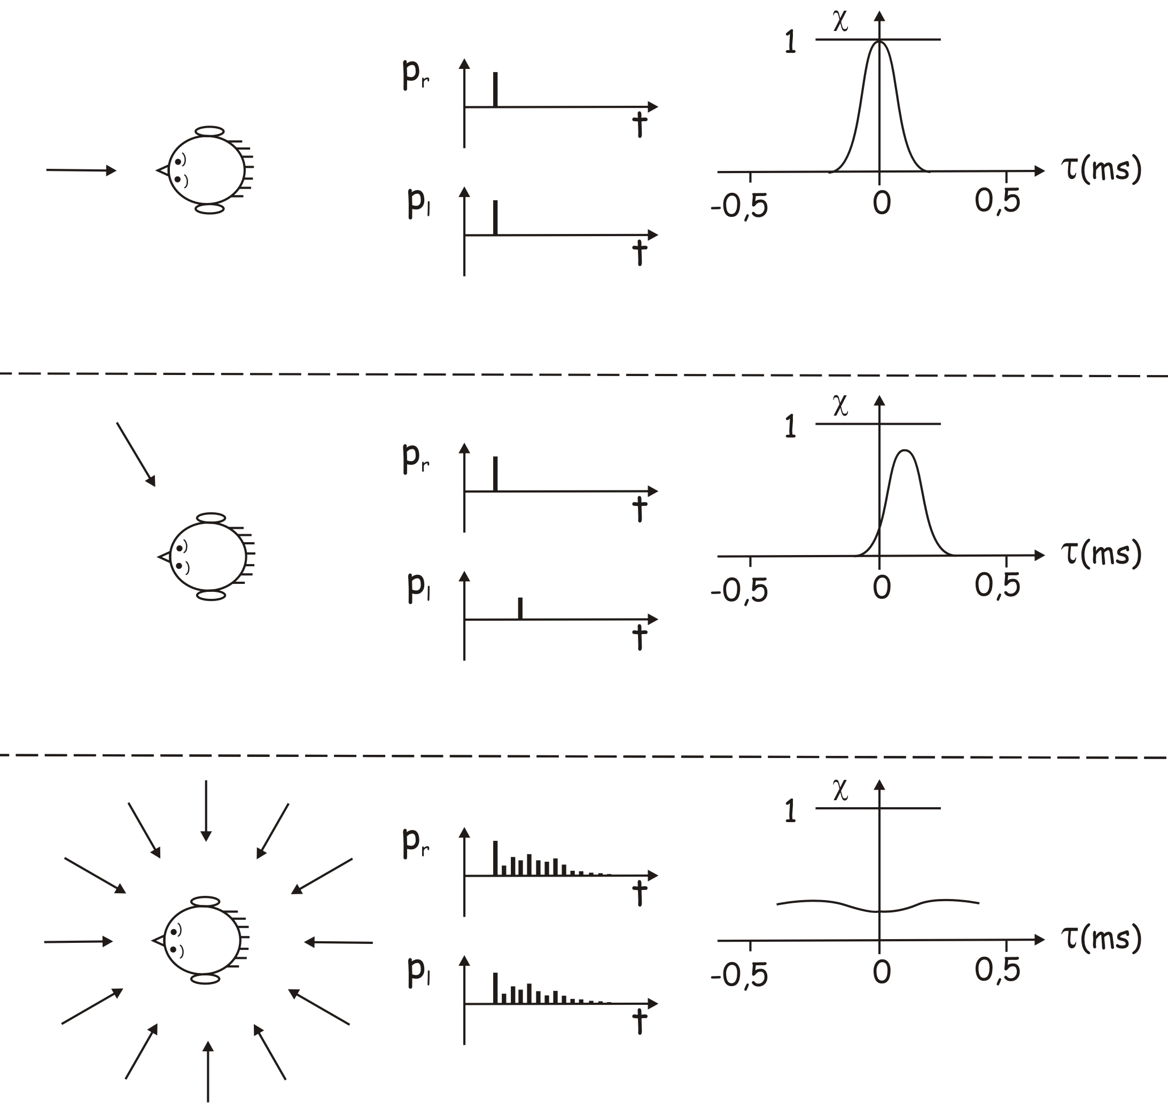
[Courtesy Mü06]

Limitations
Can these parameters (i.e. reverberation time, clarity, ITDG, etc.) cover all important aspects of room acoustics? There are two sides on the issue.

Firstly, the amount of parameters is always increasing. When the science of room acoustics was first established, the only parameter available was the reverberation time. Nowadays, the reverberation times at different octave bands can be obtained, not to mention parameters related to clarity, spaciousness and so on. Therefore, no one knows if we still have any important parameter missing.

On the other hand, there are parameters very similar to each other. It is not wise to analyse the room with all known parameters. For example, getting a parameter for clarity with respect to 80 ms is not much different from getting another parameter which determines clarity with respect to 70 ms.

Both as a remedial measure and experimental proof, models are still necessary for “acoustic delicate” rooms like concert halls. The scale of the halls can be at 1:10 or 1:20, and the acoustic properties of the walls can be approximated by materials with similar absorption coefficients.

It should be kept in mind that the ratio of wavelengths to dimensions of the concert hall should be the same in reduced models. For example, the behaviour at 10 kHz in an 1:10 model simulates the behaviour at 1 kHz in the actual room.

A failed example
The consequence of not building models can be serious. The New York Philharmonic hall (now Avery Fisher hall) is known as one of the biggest acoustic disasters in the 20th century. Millions of dollars have been spent to improve the acoustics of the hall since its opening in 1962. There were minor alternations, a complete redesign (together with a new name), and a further renovation will be carried out in the coming decade. The acoustician in charge of the project quitted the profession for a quarter of a century before participating on an experimental basis.
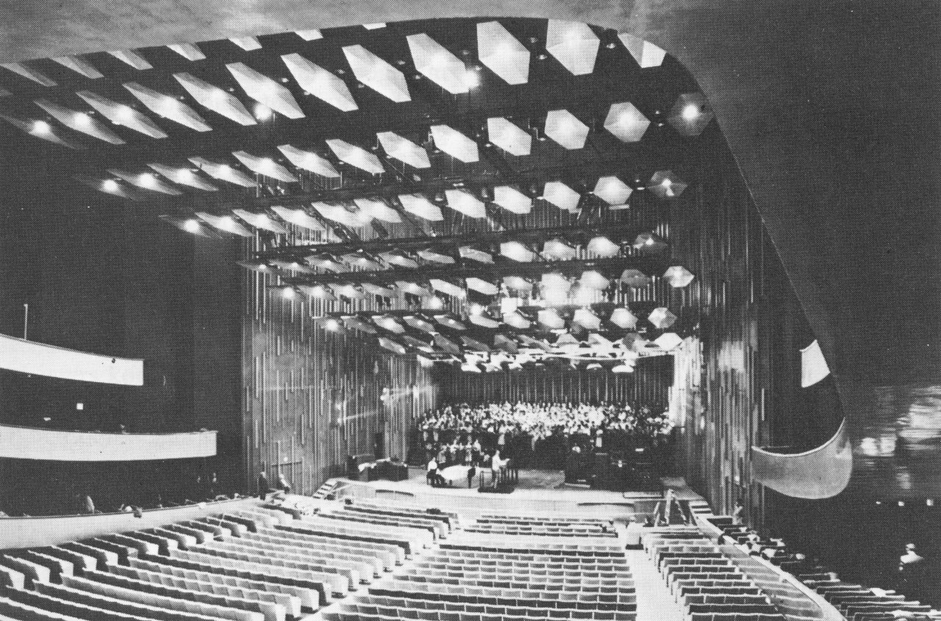
There were many reasons of not building a model: Overconfidence of the acoustician and budget constraint were two of them. Without a model, many problems in the design were not discovered before the hall was built. Firstly, concaved walls were designed to accommodate more audiences. Secondly, the design of reflectors at the hall was a reduced-size copy of a successful predecessor. As explained before, there is a minimum size of reflectors to let them reflect sound effectively. As a result, the acoustic power reflected at low frequencies is exceptionally low at the lower octave bands as shown in the graph below.
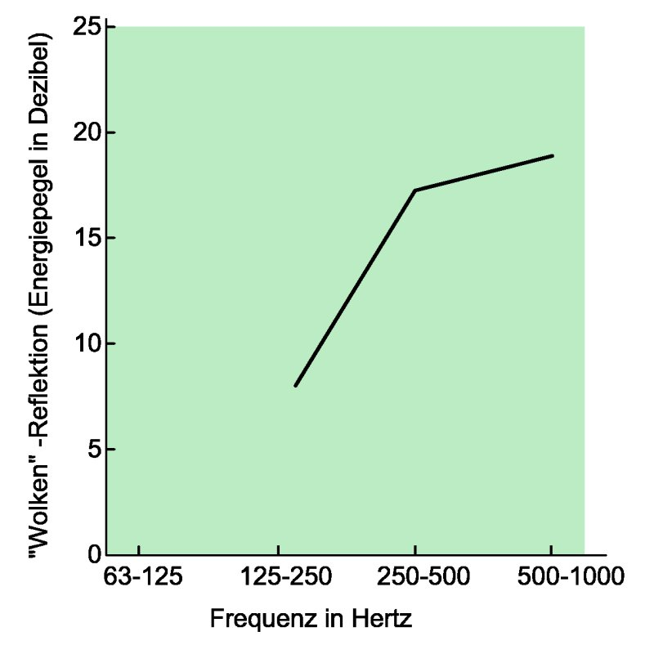
The story tells us that we should never be satisfied only by matching the parameters between a numerical model and their preferred values; instead, experiments are necessary if a detailed investigation is needed.

Solving room acoustic problems with the finite element method

The finite element (FE) method is a powerful method of solving geometrically complicated engineering problems. To facilitate the method, the governing equation is chosen, and the domain is divided into discretized “elements” having prescribed distribution of the variable inside the element. The prescribed functions are called shape functions, and they are usually linear functions.

In acoustic problems, the wave equation is the governing equation:
$$∇^{2}p=\frac{1}{c^{2}}\frac{∂^{2}p}{∂t^{2}}$$
The primary variable in room acoustic problems is the acoustic pressure, and the boundary term consists of normal acceleration on the surface.

The approaches of discretization and shape functions make the FE suitable for problems with complex geometries, but it also induces error called “discretization error”. In acoustic problems the maximum size of elements is 1/10 the shortest wavelength considered.

Numerical error
Besides the error induced by the finite element method, error can also be generated by the algorithm. This is because finite number of bits is used to represent a real or a complex number, which there exist infinite of them.

An example is shown below. It is clear that the determinant of the matrix
$$\left(\begin{matrix}1 & 0 \\ \text{1000} & 1\end{matrix}\right)$$
is 1. However, if a small numerical error is induced into the zero as
$$\left(\begin{matrix}1 & 0\text{.}\text{001} \\ \text{1000} & 1\end{matrix}\right)$$
, the determinant becomes zero!

This error is bigger when
- the matrix is asymmetric;
- the entries within the matrix are in different orders of magnitudes (e.g. in the order of 10¹⁰); and/or
- the number of significant digits is not enough.

Although such problem exists, it is not significant when the third point is overcome by storing all variables in data type “double”. Further discussion is made in [Tr97].

Conclusion
Room acoustics was established at the beginning of the 20th century. Research since that has discovered the parameters governing the behaviours of reflectors, absorbers and diffusers. Devices with desired acoustic properties can also be designed.

The acoustic quality of a room can be described by several parameters. Although numerical simulation can be used, models are still needed. One way to deal with room acoustic problems with complex geometries numerically is the finite element analysis.

References

- [Wi06] Wikipedia: Huygens' principle - Wikipedia, the free encyclopedia. http://en.wikipedia.org/wiki/Huygen%27s_principle. Wikipedia, 2006.

- [Cr82] L. Cremer, H. A. Müller and T. J. Schultz: Principles and Applications of Room Acoustics, Vol. 2. English language edition Applied Science Publishers, New York, 1982.

- [Be02] Beranek L. L.: Concert halls and opera houses: music, acoustics and architecture (2nd ed.). Springer: New York, 2002.

- [Ch04] Y. J. Chan: Final Year Project report titled “Acoustic behaviour of musical instruments”. The University of Hong Kong, 2004.

- [Ch06] Y. J. Chan: Master’s thesis titled “Acoustics of small rooms”. The Technical University of Munich, 2006.

- [Mü06] G. Müller: Presentation titled “Akustik von Musikräumen
Zauberei oder Ingenieurkunst? ”, 2006.

- [Tr97] L. N. Trefethen and D. Bau, III: Numerical Linear Algebra. Philadelphia; SIAM, 1997.

